Engineering Merit Badge: Rube Goldberg Machine Contest

Rube Goldberg was a cartoonist during the early and mid part of the 20th century. He became famous for drawing fantastically complicated machines that performed extremely simple tasks. Samples of his work can easily be found online. By the time the cartoonist retired his name became synonymous with anything characterized by excess complexity. The following cartoon is an example of a Rube Goldberg device.

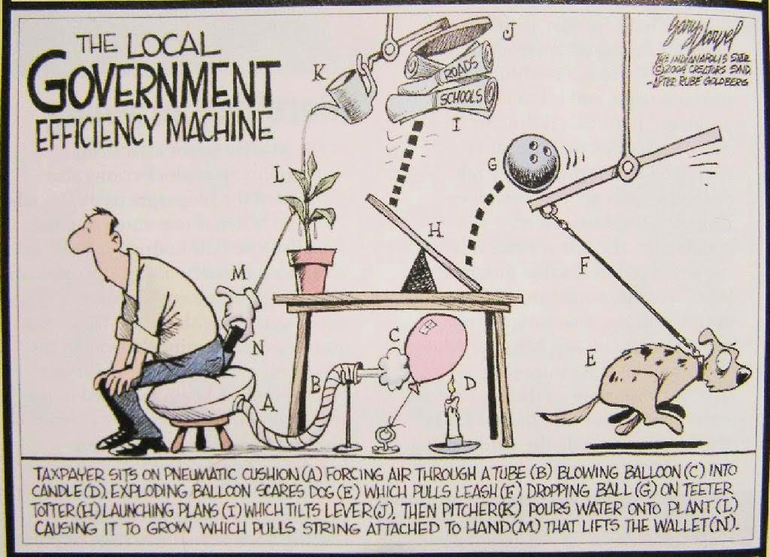

Working with one or two partners, use the Systems Engineering Process to develop your Rube Goldberg machine. Your use of this process must be documented in a journal. The Systems Engineering Process is comprised of the following seven tasks:
- State the problem. Stating the problem is the most important systems engineering task. It entails identifying customers, understanding customer needs, establishing the need for change, discovering requirements and defining system functions.
- Investigate alternatives. Alternative solutions are investigated and evaluated based on performance, cost and risk.
- Model the system. Running models clarifies requirements, reveals bottlenecks and fragmented activities, reduces cost and exposes duplication of efforts.
- Integrate. Integration means designing interfaces and bringing system elements together so they work as a whole. This requires extensive communication and coordination among all participants.
- Launch the system. Launching the system means running the system and producing outputs -- making the system do what it was intended to do.
- Assess performance. Performance is assessed using evaluation criteria and performance measures. Measurement is the key. If you cannot measure it, you cannot control it. If you cannot control it, you cannot improve it.
- Re-evaluation. Re-evaluation should be a continual and repeating process with the results of one repetition being used as the starting point for the next.

The following criteria must be followed in creating your Rube Goldberg Machine:
- All machines must include a diagram with every step clearly spelled out.
- The machines may be built out of almost anything. However, no combustible fluids, flames, or explosives are allowed.
- The machines must be confined to a one meter by one meter by one meter area.
- Flying objects and projectiles are permitted as long as they remain within the boundaries.
- Teams must include at least ten steps.
- Each machine must have three different simple machines included within its design that demonstrate the transforming of motion: lever, wheel and axle, pulley, inclined plane, wedge, screw.
- Each machine must show how one or more types of energy may be converted from one form to another: mechanical, heat, chemical, solar, and/or electrical energy.

Your task will be to turn on a battery powered light bulb. Successful completion of this project will fulfill requirements #5 and #6 of the Engineering Merit Badge. The information below will help you complete your project.

Machines
Machines are mechanical devices that help, do work. Machines make work easier by redirecting or changing the sizes of forces. A wide variety of machines have been developed to make jobs easier. Cranes lifting freight, tractors pulling farm equipment, bulldozers pushing mounds of earth, a huge compactor crushing used cars – these represent a few of the many complex mechanical devices that aid people in doing work.
The operation of a machine can be explained using the Law of Conservation of Energy. When operating a machine, you do work to use the machine. The machine then does work to move another object. With negligible friction, the energy to operate the machine (work input) equals the energy provided by the machine (work output).
Machines do not save work. Energy must be conserved. However, machines can make work easier. In many machines, we trade motion (when the input distance is larger than the output distance) for force (when the output force is larger than the input force). Even the most complex mechanical equipment follows this simple relationship.

Simple Machines
A complex machine, like a crane or bulldozer, is made up of many combinations of simpler machines. These simple machines can be classified into six types.

Lever
A lever is a length of rigid material, like a bar, which pivots-around a fixed point. This point is called the fulcrum.

Wheel and Axle
When a wheel is solidly attached to an axle, they turn together. This combination acts in the same manner as a second-class lever. A small input force applied to the outer edge of the wheel turns the
smaller axle with a larger force. Door knobs, hand cranks, and automobile cam shafts are examples.

Pulley
A pulley is also an example of a lever that rotates around a fixed point. Often, pulleys are used to redirect forces rather than increase them. The pulley at the top of a flagpole is an example.

Inclined Plane
The inclined plane, or ramp, may be the simplest of all machines. A ramp lets someone do the work necessary to raise a heavy object by allowing the object to be pushed along a long inclined surface. The longer the incline, the smaller the necessary input force.

Wedge
The wedge is a moving inclined plane. As a wedge moves through material. it cuts or forces the material apart. Knives, nails, saws, can openers – even zippers – are examples of wedges.

Screw
The screw is an inclined plane wrapped around a cylinder. As a screw is turned, material moves up or down the length of the screw. Screws are often used as fasteners. Screws used in jacks can lift cars, trucks, and even buildings.

How to complete a circuit to light a battery powered bulb:
